Logical Entity-Relationship Diagram
KAVERI 3.0 — User Management & Role-Based Access Control

1. Document control
Field | Value
Document ID | ERD-K3-UM-001
Version | 1.0
Status | Draft / companion to BRD v4.8
Project | KAVERI 3.0 — Department of Stamps and Registration
Module | User Management & RBAC
Source BRD | Finalized BRD/User Management/BRD_User_Management_v4.8.docx
Relationship to BRD | Separate companion document — not a section of the BRD
Author (BA) | Nandha Kumar
Product Owner | Prashanth
Domain expert | Prabhakar Naik
Last updated | 2026-08-30

Version | Date | Summary
1.0 | 2026-08-30 | Initial logical ERD derived from User Management BRD v4.8 masters, FRs, and occupancy / RBAC rules.

2. Purpose and scope
This document is the logical data model for the User Management module. It is issued as a stand-alone engineering / BA companion so that the BRD remains a requirements document. Physical table names, indexes, and partitioning are out of scope; implementers may split or merge tables provided the business keys, cardinalities, and rules below are preserved.
In scope: masters, mappings, identity, occupancy / transfer, session / OTP, RBAC resources, and audit.
Out of scope: citizen service case data (Marriage, Document Registration, etc.), Khajane-II DDO tables owned by Treasury, and Application Admin as a Role Master row (FR-51 — seeded system principal).

3. Logical ERD
Four figures follow. Colour bands group subject areas. Occupied count on SANCTIONED_POST is maintained by the occupancy refresh job (FR-68) and is shown as a stored derived attribute, not a separate entity. Full attributes and cardinalities are in sections 5 and 6.
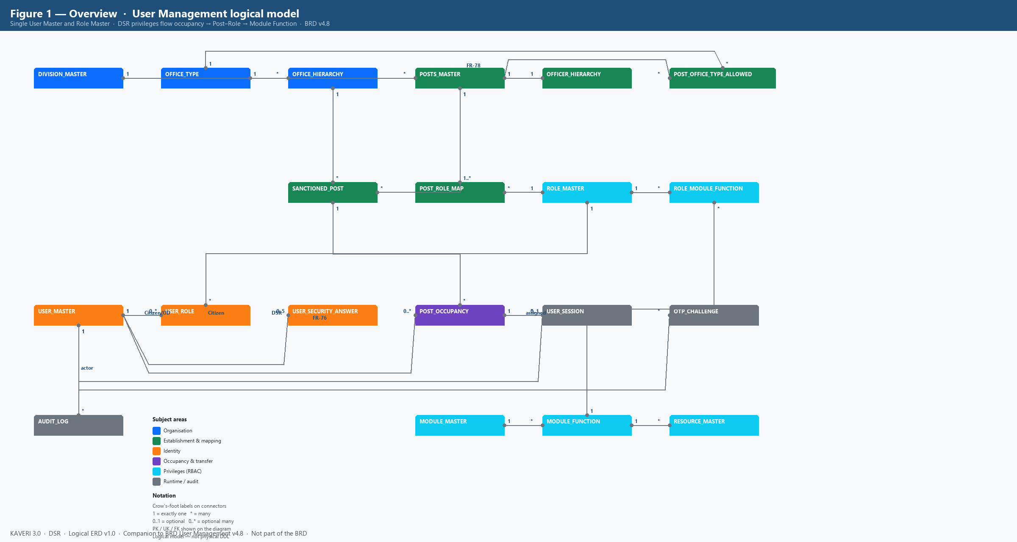
Figure 1. Overview — all logical entities and cardinalities (BRD v4.8)
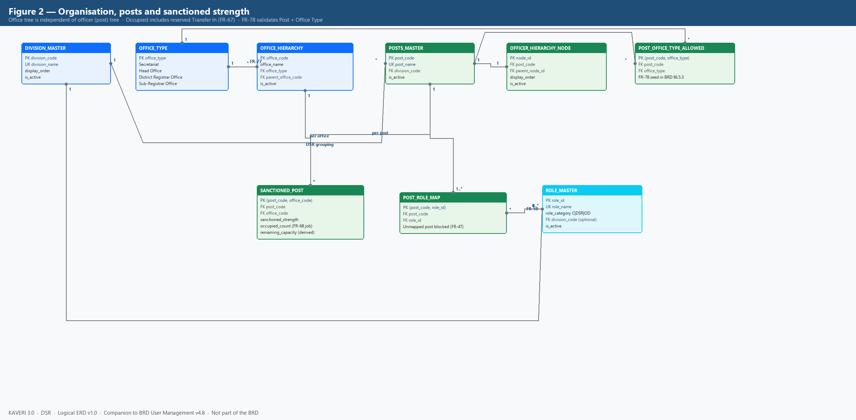
Figure 2. Organisation, posts, sanctioned strength and Post–Role mapping
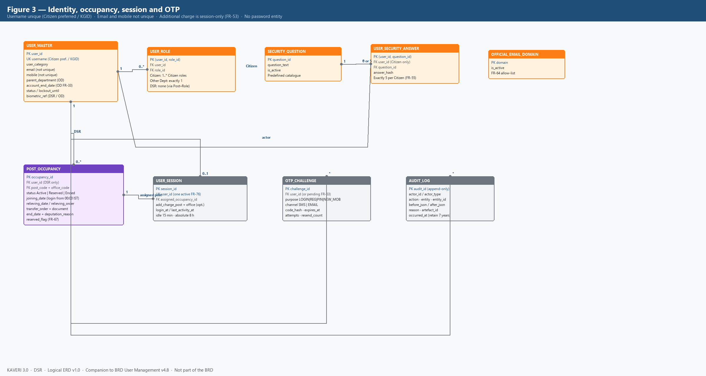
Figure 3. Identity, occupancy, session, OTP and audit
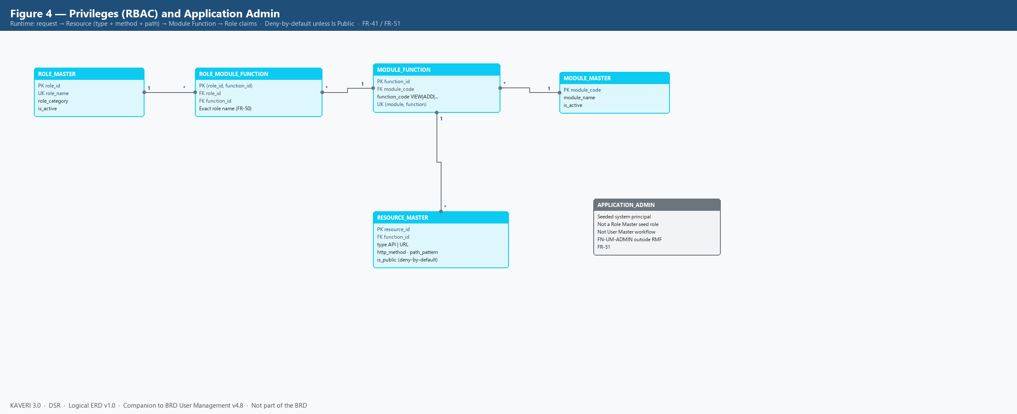
Figure 4. RBAC path Role → Module Function → Resource; Application Admin (FR-51)

4. Subject-area summary
Area | Entities | BRD anchors
Organisation | DIVISION_MASTER, OFFICE_TYPE, OFFICE_HIERARCHY | FR-59, FR-77; §6.5.1, §6.5.8
Establishment | POSTS_MASTER, OFFICER_HIERARCHY_NODE, POST_OFFICE_TYPE_ALLOWED, SANCTIONED_POST, POST_ROLE_MAP | FR-24, FR-43–FR-49, FR-66–FR-68, FR-78; §6.5.3, §6.5.7
Identity | USER_MASTER, USER_ROLE, SECURITY_QUESTION, USER_SECURITY_ANSWER, OFFICIAL_EMAIL_DOMAIN | FR-01–FR-04, FR-16, FR-33–FR-35, FR-55, FR-62–FR-65
Occupancy & transfer | POST_OCCUPANCY (Transfer In / Relieving / deputation End Date as attributes) | FR-26, FR-30, FR-52, FR-57–FR-61, FR-66–FR-68
RBAC | ROLE_MASTER, MODULE_MASTER, MODULE_FUNCTION, RESOURCE_MASTER, ROLE_MODULE_FUNCTION | FR-18, FR-36–FR-42, FR-50–FR-51
Runtime / audit | USER_SESSION, OTP_CHALLENGE, AUDIT_LOG; APPLICATION_ADMIN (not a Role Master entity) | FR-05–FR-13, FR-22, FR-51, FR-69–FR-76

5. Entity catalogue

5.1 DIVISION_MASTER
Enumerated DSR organisational divisions. Free-text division labels are not permitted on new or edited records (FR-77).
Attribute | Type / notes | Constraints
division_code | String, e.g. DIV-ENFORCEMENT | PK
division_name | String | UK; required
display_order | Integer | Seed 1–8
is_active | Boolean | Soft disable

5.2 OFFICE_TYPE
Lookup of Secretariat, Head Office, District Registrar Office, Sub-Registrar Office. Distinct from role names (SRO is an office type, not a Role Master name).
Attribute | Type / notes | Constraints
office_type | Enum / code | PK
display_name | String | Required

5.3 OFFICE_HIERARCHY
Concrete DSR offices. Tree: MS Building (Secretariat, root, OFF-MS-BLDG) → IGR Office (Head Office) → District Registrar Offices → Sub-Registrar Offices (FR-59). Office span for Transfer Out / Transfer In is the session office plus descendants.
Attribute | Type / notes | Constraints
office_code | String, e.g. OFF-SRO-YESH | PK
office_name | String | Required
office_type | FK OFFICE_TYPE | Required
parent_office_code | FK OFFICE_HIERARCHY | Null only for MS Building
is_active | Boolean | Soft disable with audit

5.4 POSTS_MASTER
DSR establishment posts, distinct from Role Master. Division-specific posts (FR-49). Post name is the referential-integrity key used by Post–Role and Hierarchy (FR-50).
Attribute | Type / notes | Constraints
post_code | String, e.g. POST-SR | PK
post_name | String, character-for-character match | UK; required
division_code | FK DIVISION_MASTER | Required (FR-77)
is_active | Boolean | Soft disable

5.5 OFFICER_HIERARCHY_NODE
Reporting tree of Posts (not of people). Each node references a Post; optional parent is also a Post node (FR-43, FR-44). Used for FR-53 additional-charge cascade and Transfer Out / In immediate-parent filter.
Attribute | Type / notes | Constraints
node_id | Surrogate | PK
post_code | FK POSTS_MASTER | UK recommended (one node per post)
parent_node_id | FK self | Null at ACS / Secretary
display_order | Integer | Optional
is_active | Boolean | Soft disable; history retained

5.6 POST_OFFICE_TYPE_ALLOWED
Which Post codes may be sanctioned at which Office Types (FR-78). Example: POST-ACS-SEC only at Secretariat; POST-SR / POST-FDA-ENF / POST-DEO only at Sub-Registrar Office.
Attribute | Type / notes | Constraints
post_code | FK POSTS_MASTER | PK part
office_type | FK OFFICE_TYPE | PK part

5.7 SANCTIONED_POST
Approved headcount per Post at each Office (FR-24, FR-48). Occupied count includes active occupancies and reserved Transfer In (FR-67) and is recalculated by the midnight occupancy refresh job (FR-68). FR-66(a) available capacity = Occupied < Strength. FR-66(b) wholly unoccupied = Occupied = 0 (FR-53).
Attribute | Type / notes | Constraints
post_code | FK POSTS_MASTER | PK part; must have Post–Role mapping (FR-47)
office_code | FK OFFICE_HIERARCHY | PK part
sanctioned_strength | Integer ≥ 0 | Required
occupied_count | Integer, job-maintained | Includes reserved FR-67
remaining_capacity | Derived Strength − Occupied | May be stored or computed

5.8 ROLE_MASTER
Single role catalogue for Citizen, DSR, and Other Department (FR-16, FR-35). Unique role names include division context (FDA (Enforcement), not bare FDA). Application Admin is not a seed row (FR-51).
Attribute | Type / notes | Constraints
role_id | Surrogate | PK
role_name | String | UK; FR-50 exact match
role_category | Citizen | DSR | Other Department | Required
division_code | FK DIVISION_MASTER | Optional; DSR seed grouping
description | String | Optional
is_active | Boolean | Disable blocked if still in use

5.9 POST_ROLE_MAP
One Post may map to multiple Roles only within the same functional scope (FR-47). Sanction or assignment of an unmapped Post is blocked. DSR session privileges come from this mapping for the selected occupancy — not from USER_ROLE.
Attribute | Type / notes | Constraints
post_code | FK POSTS_MASTER | PK part
role_id | FK ROLE_MASTER | PK part; name must match Role Master

5.10 USER_MASTER
Single user store. Username is the only unique login identifier (FR-04, FR-62): preferred Username for Citizens; KGID for DSR Officers and Other Department users. Email and mobile are not unique. No password attribute exists (FR-09).
Attribute | Type / notes | Constraints
user_id | Surrogate | PK
username | Citizen preferred / departmental KGID | UK across all categories
user_category | Public (Citizen) | DSR Officer | Other Department | Required
name_parts | First / middle / last | Required; name locked on standard edit
email | Citizen personal / departmental official | Not unique; FR-64 domain check for DSR/OD
mobile | SMS login OTP target | Not unique
parent_department | String | Other Department only
designation | String | Other Department only
account_end_date | Date | Optional; OD auto-deactivate (FR-33)
status | Active | Suspended | Deactivated | Deactivation requires reason
lockout_until | Timestamp | FR-73 login lock 15 min
reset_lockout_until | Timestamp | FR-56 / FR-73 reset lock 30 min
biometric_ref | UIDAI-compliant token | DSR and Other Department; every login
photo / id_proof_ref | Document store keys | Departmental creation
authorisation_letter_ref | Document store | Other Department should

5.11 USER_ROLE
Direct role assignment for Citizens (one or more Citizen-category roles) and Other Department users (exactly one Other Department role — FR-17 / FR-34). DSR Officers do not receive USER_ROLE rows; their roles are resolved Post occupancy → POST_ROLE_MAP at login (FR-52, FR-38).
Attribute | Type / notes | Constraints
user_id | FK USER_MASTER | PK part
role_id | FK ROLE_MASTER | PK part; Role Category must match User Category

5.12 SECURITY_QUESTION and USER_SECURITY_ANSWER
Citizen self-registration captures five distinct questions from a predefined list; answers stored hashed only (FR-55). Not held for DSR or Other Department users.
Entity | Attribute | Constraints
SECURITY_QUESTION | question_id, question_text, is_active | Predefined catalogue
USER_SECURITY_ANSWER | user_id, question_id, answer_hash | Exactly 5 per Citizen; never displayed

5.13 OFFICIAL_EMAIL_DOMAIN
Optional allow-list for DSR and Other Department official email (FR-64).
Attribute | Type / notes | Constraints
domain | e.g. karnataka.gov.in | PK
is_active | Boolean

5.14 POST_OCCUPANCY
Assignment of a DSR user to a sanctioned Post at an Office. Multiple occupancies per user are allowed. Transfer In, Relieving, reserved handover (FR-67), and deputation End Date (FR-30) are modelled as attributes and status on this entity rather than separate header tables. Login uses occupancies that are Active (Joining Date reached); Reserved occupancies count toward Occupied but cannot be selected until 12:00 AM IST on Joining Date (FR-61).
Attribute | Type / notes | Constraints
occupancy_id | Surrogate | PK
user_id | FK USER_MASTER | User Category = DSR Officer
post_code + office_code | FK SANCTIONED_POST | Must have available capacity unless FR-67
status | Active | Reserved | Ended | Job transitions at midnight IST
joining_date | Date | Transfer In; login from 00:00 IST that day
transfer_order_no / document_id | String / artefact | FR-60
relieving_date | Date | Mapping retained through 23:59 IST of that date
relieving_order_no / document_id | String / artefact | FR-57
end_date | Date | Deputation only (FR-30); not a substitute for relieving
deputation_reason | Code | Mandatory if end_date set
reserved_flag | Boolean | FR-67; counts as occupied immediately
created_by / created_at | Actor + timestamp | Immediate-parent + office-span rules

5.15 USER_SESSION
One active session per Username (FR-76). Idle 15 minutes (FR-74); absolute 8 hours (FR-75). For DSR: assigned_occupancy_id is the FR-52 post for the session. Additional charge (FR-53) is session-only — it does not create a POST_OCCUPANCY row and does not require an order. While additional charge is set, Module Function claims come only from that subordinate post (FR-38).
Attribute | Type / notes | Constraints
session_id | Surrogate | PK
user_id | FK USER_MASTER | UK among active sessions
assigned_occupancy_id | FK POST_OCCUPANCY | DSR only; null for Citizen / OD
add_charge_post_code | FK POSTS_MASTER | Optional; same office as assigned
add_charge_office_code | FK OFFICE_HIERARCHY | Must equal assigned occupancy office
login_at / last_activity_at / expires_at | Timestamps | IST clock

5.16 OTP_CHALLENGE
OTP/PIN issuance for login (SMS only), Citizen registration (email + mobile), lost-mobile PIN (email), and new-mobile verification. Policy FR-69–FR-72: 6 digits; login 5 min; registration/PIN 10 min; 3 failures invalidate; 30 s resend; max 3 resends / 15 min.
Attribute | Type / notes | Constraints
challenge_id | Surrogate | PK
user_id | FK USER_MASTER (or pending registration token) | Nullable during FR-63
purpose | LOGIN | REG_EMAIL | REG_MOBILE | RESET_PIN | NEW_MOBILE | Required
channel | SMS | EMAIL | Login OTP never emailed (FR-10)
code_hash | Hash | Never stored clear
expires_at / attempt_count / resend_count | Policy attributes | FR-69–FR-72

5.17 MODULE_MASTER, MODULE_FUNCTION, RESOURCE_MASTER, ROLE_MODULE_FUNCTION
Access path: session roles → ROLE_MODULE_FUNCTION → MODULE_FUNCTION → RESOURCE. Runtime match is Type + Method + Path with most-specific pattern winning; unmatched non-public resources deny (FR-41). Is Public = Yes allows unauthenticated access. Application Admin uses FN-UM-ADMIN outside this mapping (FR-51).
Entity | Key attributes | Notes
MODULE_MASTER | module_code, module_name, is_active | e.g. Marriage Registration, Encumbrance Search
MODULE_FUNCTION | function_id, module_code, function_code | VIEW, ADD, EDIT, APPROVE, SIGN, PRINT, DOWNLOAD, FN-UM-ADMIN
RESOURCE_MASTER | resource_id, function_id, type, method, path_pattern, is_public | Roles do not store raw URL lists
ROLE_MODULE_FUNCTION | role_id, function_id | Role name must match Role Master exactly (FR-50)

5.18 AUDIT_LOG
Append-only log of create/update/delete, login, mobile/email change, lost-mobile reset, Transfer Out / In, additional charge switch, occupancy-refresh job, and access denials. Retention at least seven years. Who, when, before/after, reason, artefact id.
Attribute | Type / notes | Constraints
audit_id | Surrogate | PK; no updates/deletes
actor_id / actor_type | User or job / Application Admin | Required
action / entity / entity_id | String | Required
before_json / after_json | JSON | Masked PII (mobile)
reason / artefact_id | String | GO / order document
occurred_at | Timestamp IST | Required

6. Relationship catalogue
Parent | Child | Cardinality | Rule
DIVISION_MASTER | POSTS_MASTER | 1 : * | Every post has a Division Code (FR-77).
DIVISION_MASTER | ROLE_MASTER | 1 : 0..* | Optional grouping for DSR seed roles.
OFFICE_TYPE | OFFICE_HIERARCHY | 1 : * | Four office types only.
OFFICE_HIERARCHY | OFFICE_HIERARCHY | 1 : 0..* | Parent office; MS Building is root.
POSTS_MASTER | OFFICER_HIERARCHY_NODE | 1 : 1 | Every hierarchy node Post exists in Posts Master (FR-44).
OFFICER_HIERARCHY_NODE | OFFICER_HIERARCHY_NODE | 1 : 0..* | Immediate parent post (FR-43).
POSTS_MASTER | POST_OFFICE_TYPE_ALLOWED | 1 : * | FR-78; required before sanction.
OFFICE_TYPE | POST_OFFICE_TYPE_ALLOWED | 1 : * | FR-78.
POSTS_MASTER | SANCTIONED_POST | 1 : * | Strength is per Post per Office.
OFFICE_HIERARCHY | SANCTIONED_POST | 1 : * | Office Type must be allowed for that Post.
POSTS_MASTER | POST_ROLE_MAP | 1 : 1..* | Unmapped post cannot be sanctioned or assigned (FR-47).
ROLE_MASTER | POST_ROLE_MAP | 1 : 0..* | Exact unique role name (FR-50).
USER_MASTER | USER_ROLE | 1 : 0..* | 0 for DSR; 1 for Other Department; 1..* for Citizen.
ROLE_MASTER | USER_ROLE | 1 : 0..* | Role Category must equal User Category (FR-34).
USER_MASTER | USER_SECURITY_ANSWER | 1 : 0 or 5 | Citizens only (FR-55).
SECURITY_QUESTION | USER_SECURITY_ANSWER | 1 : * | Five distinct questions per Citizen.
USER_MASTER | POST_OCCUPANCY | 1 : 0..* | DSR Officers only; multiple posts allowed (FR-26).
SANCTIONED_POST | POST_OCCUPANCY | 1 : 0..* | Blocked when Occupied ≥ Strength unless FR-67 reservation.
USER_MASTER | USER_SESSION | 1 : 0..1 active | Last-login-wins (FR-76).
POST_OCCUPANCY | USER_SESSION | 1 : 0..* | Assigned post for DSR session (FR-52).
USER_MASTER | OTP_CHALLENGE | 1 : 0..* | Also used pre-account for FR-63.
MODULE_MASTER | MODULE_FUNCTION | 1 : * | FR-39.
MODULE_FUNCTION | RESOURCE_MASTER | 1 : * | FR-40.
ROLE_MASTER | ROLE_MODULE_FUNCTION | 1 : * | Except Application Admin (FR-51).
MODULE_FUNCTION | ROLE_MODULE_FUNCTION | 1 : * | FR-37.
USER_MASTER | AUDIT_LOG | 1 : * | Actor; jobs may write with actor_type = SYSTEM.

7. Category-specific population rules
User Category | Username | USER_ROLE | POST_OCCUPANCY | Security answers | Session extras
Public (Citizen) | Preferred Username (FR-62) | Citizen roles assigned at registration | None | Exactly 5 (FR-55) | No post selection
DSR Officer | KGID = Username (FR-64) | None — roles via Post–Role | 1..* sanctioned posts | None (FR-65) | FR-52 assigned post; FR-53 additional charge on session only
Other Department | KGID = Username | Exactly one Other Department role | None (Posts Master N/A) | None | No post selection; optional account_end_date (FR-33)

8. Derived facts (not separate entities)
Fact | How obtained
Session Module Function claims | Citizen/OD: USER_ROLE → RMF. DSR without additional charge: assigned occupancy → POST_ROLE_MAP → RMF. DSR with FR-53 active: additional-charge post only (FR-38).
Office span | Walk OFFICE_HIERARCHY descendants of session office (FR-59).
Immediate-parent transfer filter | OFFICER_HIERARCHY_NODE.parent of the target post = actor session post (FR-57, FR-60).
Available capacity FR-66(a) | SANCTIONED_POST.occupied_count < sanctioned_strength.
Wholly unoccupied FR-66(b) | occupied_count = 0 (reserved Transfer In counts as occupied).
Occupied count | Count of POST_OCCUPANCY in Active or Reserved for that Post+Office; refreshed by FR-68 job.

9. Explicit non-entities
Password / credential secret — authentication is OTP (and biometrics for departmental users) only (FR-09).
Application Admin — deployment-seeded system principal with FN-UM-ADMIN; not created via User Master workflow and not a Role Master seed role (FR-51). Shown on the diagram for completeness only.
Primary / Secondary role flags — removed; DSR context is assigned post vs additional charge (FR-52 / FR-53).
Separate Citizen vs Department user databases — forbidden; one USER_MASTER and one ROLE_MASTER (FR-16).

10. Alignment to BRD v4.8
This ERD is a companion to BRD_User_Management_v4.8.docx. If a functional requirement and this model ever diverge, the BRD requirement text prevails until this ERD is revised. Physical LLD / DDL should trace to the entity and relationship IDs in sections 5 and 6.
Related documents: BRD-K3-UM-001 v4.8 (requirements) · ERD-K3-UM-001 v1.0 (this document).

